**PCPF Lab**

**Lab Assignment number 04**

**Name:** Aamir Ansari **Batch:** A **Roll** no. 01

**Aim:** To execute the following on the prelude command prompt

**Problem Statement:**

1. Converts temperatures in C to F

2. Use map to convert a string into a list of Booleans, each element in the

new list representing whether or not the original element was a lower-case character,

that is, it should take the string aBCde and return [True,False,False,True,True].

3. Find factorial of number

4. Display square of numbers given in list

**Solution:**

Converts temperatures in C to F

convert :: Float->Float

convert n = (n*(9/5.0))+32

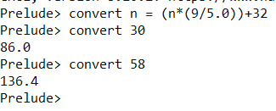

Use map to convert a string into a list of Booleans, each element in the

new list representing whether or not the original element was a lower-case character,

that is, it should take the string aBCde and return [True,False,False,True,True].

import Data.Char

convert x = map(\x -> isLower x) x

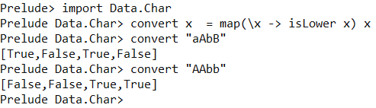

Find factorial of number

fac :: (Integral a) => a -> a

fac n = product [1..n]

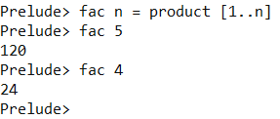

Display square of numbers given in list

square x = map(^2) x

